FI01 -

Functionality
Bank Master Records are stored in the bank directory. Their details are stored also in Customer / Vendor Master Data and are used by payment program to prepare payment documents. You can create new Bank Master Record using transaction FI01 or you during maintaining Cust. / Vendor Master Data.

Scenario
You want to store in the system the details of a new bank.

Requirements
No.

Menu Path | Accounting → Financial Accounting → Banks → Master Data → Bank Master Record → FI01 - Create
Transaction Code | FI01

1. Double click on FI01 – Create.

Create bank: Initial screen

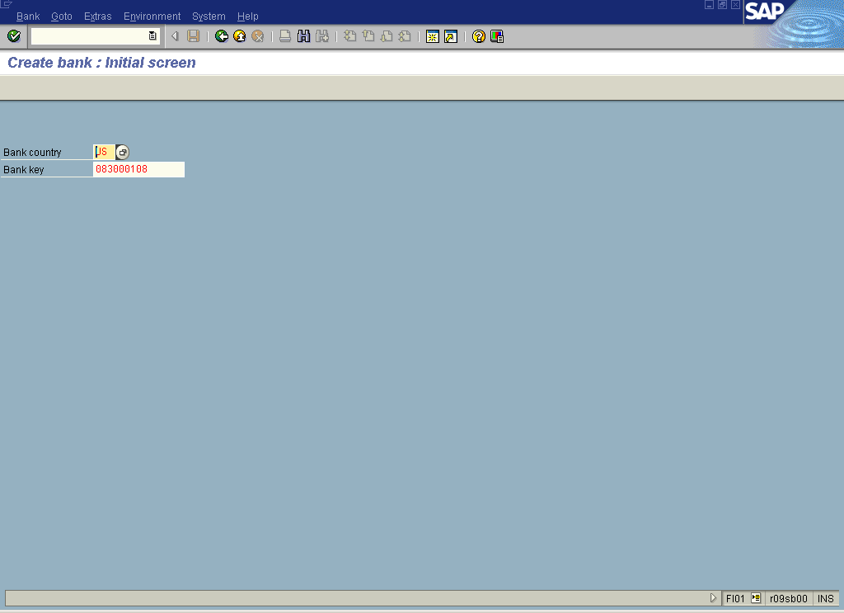

2. Update the following fields:

Field Name | Field Description | Values
Bank country | Enter country code here | Example: UUS
Bank key | Bank key is the bank code. This field is country specific. Usually the bank key consists of first 8 digits of your full bank account number and is followed by “hyphen” - | Enter value in Bank key.  Example: 083000108

3. Click Enter Button . The system will ask you to enter bank details:

Create bank: Detail screen

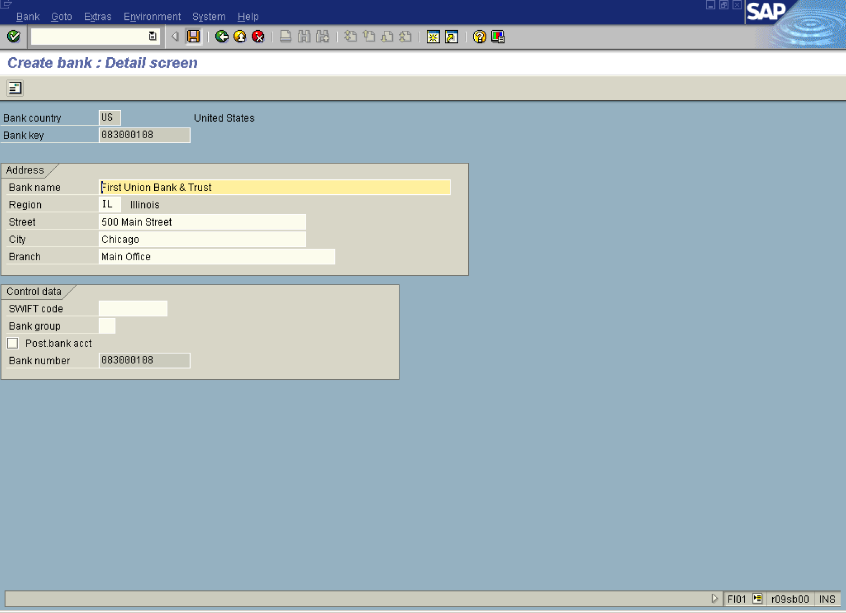

4. Update the following fields:

Field Name | Field Description | Values
Bank name | Name of the bank | Example: First Union Bank & Trust
Region | Country specific field. Enter a state code here | Example: IL
Street | Street name | Example: 500 Main Street
City | City in which the bank is located | Example: Chicago
Branch | Name identifying the branch of the bank, if the bank is part of a multibranch system | Example: Main Office

5. Click Enter Button .
6. Your entry is ready. Click Save Button to store bank details in the database.

